Imagine we have 3 actor A, B and C.

A wants to send message m­A to actor C.

B wants to send message m­B to actor C.

There is no message in actor C.

**Assume m­A is a pure data message and mB is not.**

Even if we give higher priority to pure data messages there are some scenarios that mB will be executed before m­A . A scenario is given bellow.

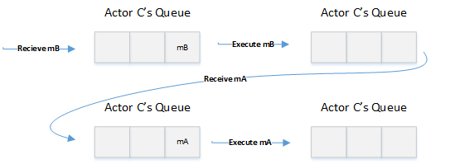

The ideal scenario that both messages are first received by actor C and after that actor C starts its execution.